ER/EER Diagram of The System

For this research, the conceptual data model was designed to the movie ticket reservation system developed.
The core idea of the system was to enable customers to reserve seats for movies, make their payments, and get screening time information. The relationships between the entities were identified with ER/EER modeling techniques.
Seven entities were defined in the model: Customer, Movie, Screening Time, Cinema Hall, Seat, Reservation, and Payment. These entities were the breakdown of fully representing the transaction steps that form the core application area of the system.
- Customer: The users who make reservations.
- Movie: The movies to be shown in the cinema.
- Showtime: The showtimes according to the dates and times of the movies.
- Center: Includes the information of the screening room.
- Seat: The numbered seats for each center.
- Reservation: The ticket record created by the customer by choosing a specific seat and showtime.
- Payment: The payment records for reservation transactions.

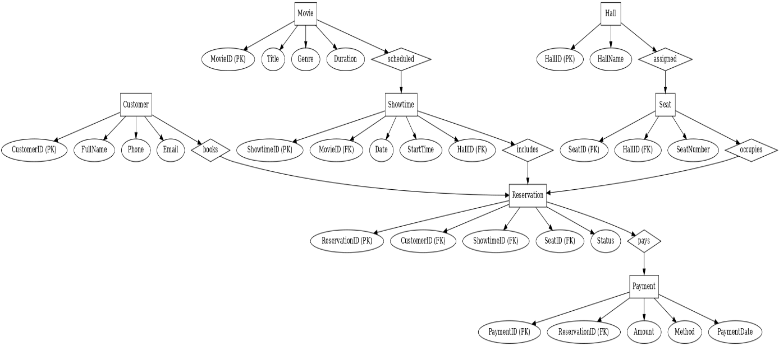
This diagram visually represents the system's overall data flow, entity structure, and relationship connections.

Logical Design

This section discusses the transformation of the conceptual framework derived from the ER/EER model in Section 3 into a relational data model. Each entity specified in the ER model has been transformed into a table for the relational database; primary keys and foreign keys are explicitly defined.
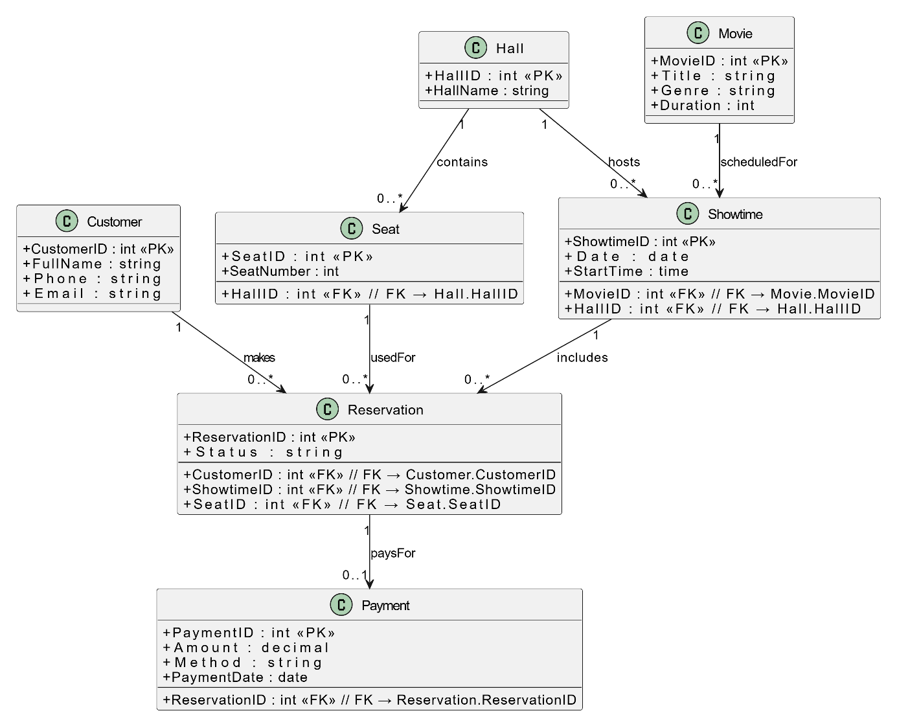

By looking at the relationships between these entities, it is understood that one customer can create many reservations; each movie can have multiple showtimes; and every showtime is linked to a particular center and seat arrangement. In addition, every reservation is linked to the payment table. Furthermore, each reservation is associated with a payment table. This structure creates a relational chain that facilitates data flow.
This logical design:
• Ensures data integrity,
• Provides an organized table structure for relational querying.
At this stage, the conceptual model has been fully transformed into a relational database format.

Reference

- TutorialsPoint. (2024). ER Model – Overview. https://www.tutorialspoint.com/dbms/dbms_data_models.htm
- Draw.io Documentation. (2024). How to Build ER Diagrams. https://www.diagrams.net
- Chen, P. (1976). The Entity-Relationship Model: Toward a Unified View of Data. ACM Transactions on Database Systems, 1(1), 9–36.
- Connolly, T., & Begg, C. (2015). Database Systems: A Practical Approach to Design, Implementation and Management (6th ed.). Pearson.
- Elmasri, R., & Navathe, S. (2016). Fundamentals of Database Systems (7th ed.). Pearson.

